Year 9 VLE
February

Home Economics

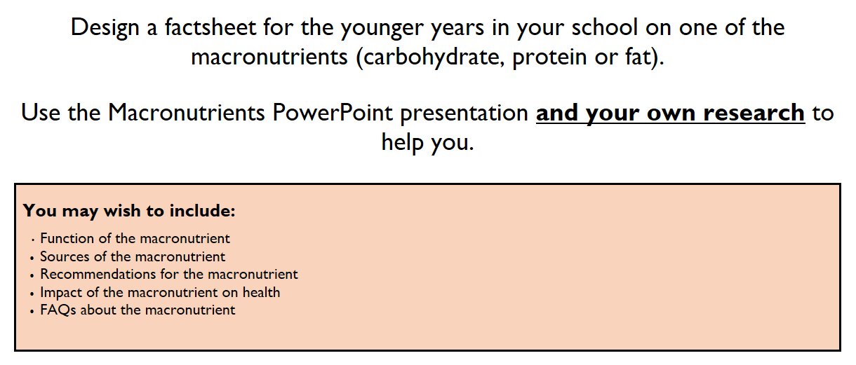
Home Economics Task

Click here for the presentation

History

History Task
Mary Queen of Scots
The Murder of David Rizzio

Create a one page newspaper article covering the murder of David Rizzio.
Success Criteria
Your article should include:-
A headline
- One picture
- A description of who Rizzio was, and his relationship to Mary Queen of Scots
- The reasons why the murder took place
- The events of the murder

You can use your History notes and any books or websites you research to help you. Here is one website which you might want to refer to:
https://www.tudorsociety.com/9-march-1566-murder-david-rizzio/

Music

Music Task
Performing a Jig
Listen to and follow the music of ‘The Three Note Jig’. You will find a copy of the Music in the YouTube Video at the bottom of the screen. There will also be a copy of the music along side this.

Notice how the time signature is 6/8.
Notice how the music only uses 3 notes.
Notice how there are 2 sections:
Section A is bars 1 – 8
Section B is bars 9 – 16
Notice how bars 5 – 8 are almost the same as bars 1 - 4.
Notice how bars 1-4 are repeated
Notice how bars 12 – 16 are almost the same as bars 9 - 12.
Notice how the rhythm of Section B is different from Section A: In your Book, write down what is different about the rhythm?

Listen to the music until you become familiar with it.
When you feel ready, slowly, bar by bar, try to play the jig.
Write down the difficulties you experience for each 2-bar phrase:

Difficulties for:
Bars 1-2
Bars 3-4
Bars 7-8
Bars 9-10
Bars 11-12
Bars 15-16
CLICK HERE to listen to the Sound File on YouTube.
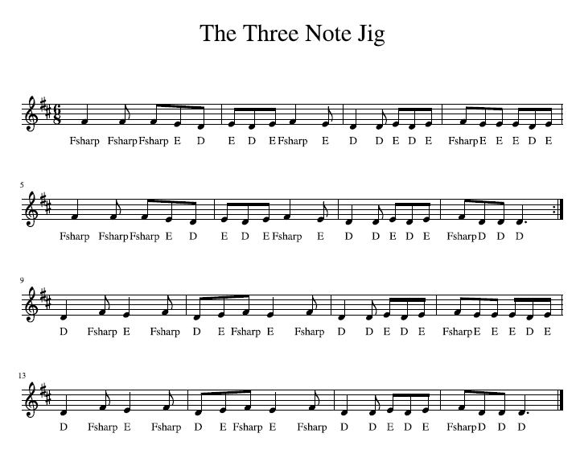

Science

Science Task
On the Virtual Learning Day, Year 9 pupils will be expected only to research the task. Pupils need to show evidence of the searches made and reference material made use of by storing bookmarks and saving print screen images of the results returned from any search engines used. Evidence must also be stored of image references that may be used for the final newspaper report.

Sexual reproduction relies on having at least two organisms and there are many reasons that this process may not work. Cloning is a scientific method used to reproduce organisms quicker and in much greater numbers without relying on other organisms or the environment. Each of these clones will have the same DNA and the same characteristics. However, cloning does have certain drawbacks.

Pupils are to take on the role of a scientific journalist to produce a newspaper report for a fictional school newspaper. Pupils will outline the recent scientific advances in cloning using the following title, ‘Cloning – advantages & disadvantages’.

Pupils will use the following skills of exploring the topic, expressing their ideas and exhibiting the information in an electronic format (this will also include images in appropriate formats).

Pupils will gather information in an organised manner from a range of current reference material from the following selection; TV, newspapers, science magazines, reference books, Internet and Intranet (Learning NI), CD-ROMs etc.

Pupils must analyse the evidence, making sure that it is relevant and unbiased, they will display the information in a newspaper report which will include at least one image.

Throughout the task the pupils will keep an electronic record of their searches, information used and images obtained for the task. This will be organised in 'My Documents' and verified by a number of screen shots.

Work individually to write a newspaper report on:
"Cloning - Advantages and Disadvantages"

Success Criteria for complete task
You must work individually as a journalist to…
- Produce a media report using Microsoft Word that includes images.
(This report should be for inclusion in a fictional Year 9 Newspaper.)
- Produce a report that is 250 words in length.
- Gather information in an organised manner from a range of current reference material from the following selection; TV, newspapers, science magazines, reference books, Internet and Intranet (Learning NI), CD-ROMs etc.
- Analyse the evidence, making sure that it is relevant and unbiased.
- Display the information in a relevant format.
- Include a separate bibliography listing the reference material used.
- Use a print screen shot showing how Internet bookmarks have been stored in an organised way.
- Use a print screen shot to show your stored report and image files used (all files stored must have an appropriate file name).
- Upload the report and image files to your personal KS3 ICT e-portfolio (MAPS software).
- Display text in a variety of formats, demonstrating a clear understanding of audience and purpose.
- Use page numbers (if appropriate).
- Use tables and tabs to organise text.
- Format a table (borders, shading, merging cells, changing widths and heights) to display advantages and disadvantages of cloning.
Format lists using bullet points and numbering.

