Year 8 VLE February

English

English Task

**Complete Tasks 37 and 38 in your Y8 English Homework Booklet**

Task 37: this is a reading skills development exercise which will help you prepare for your May exam. It should take 30-40 minutes for you to complete. Make sure when you are answering Q3 and Q4 that you are writing in PEE paragraphs

Task 38: this task will help build your vocabulary. It should take 10-20 minutes to complete.

Geography

Geography Task

**Get Active 5.3 Textbook - Drawing a Climate Graph**

**Building on previous knowledge** - climate is the average weather experienced by an area, it only covers precipitation (rainfall) and temperature, giving average conditions for each month of the year and is shown on a climate graph.

**Task 1:** Watch the YouTube Video to the right (or click the link below the video) and watch how to draw a Climate Graph.

[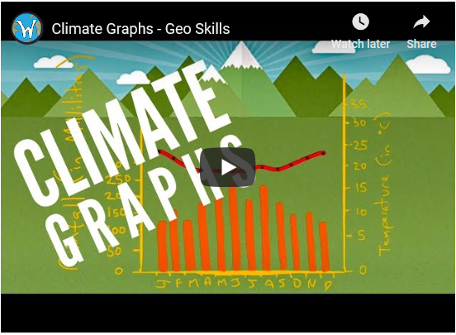](https://www.youtube.com/watch?v=Wv6yHl0LpgM&feature=youtu.be)

[**https://www.youtube.com/watch?v=Wv6yHl0LpgM**](https://www.youtube.com/watch?v=Wv6yHl0LpgM)

**Task 2:** Complete Get Active 5.3 from Page 65 in your textbook - put the graph and answers in your notebook.

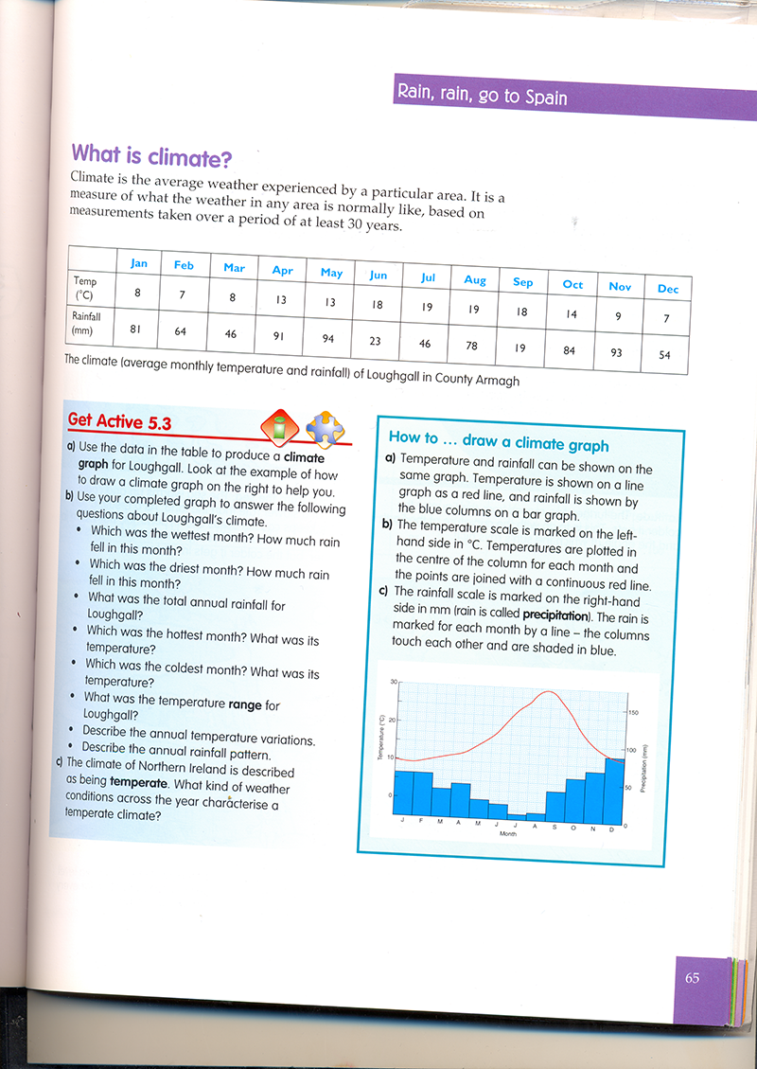

ICT

ICT Task

**Learning Objectives:**

* Learn about Health and Safety within ICT.
* Understand what is meant by Risk Assessment and how employers are responsible for the health and safety of their employees.

Learn what precautions can be taken to reduce health and safety risks in the workplace.

**Task 1**

Click on the link below to download and open the "Health and Safety PowerPoint"

<http://hunterhousecollege.org.uk/wp-content/uploads/2019/02/Yr8HealthandSafetyVLEDay.ppt>

Work through this PowerPoint and use the content to answer the multiple choice below

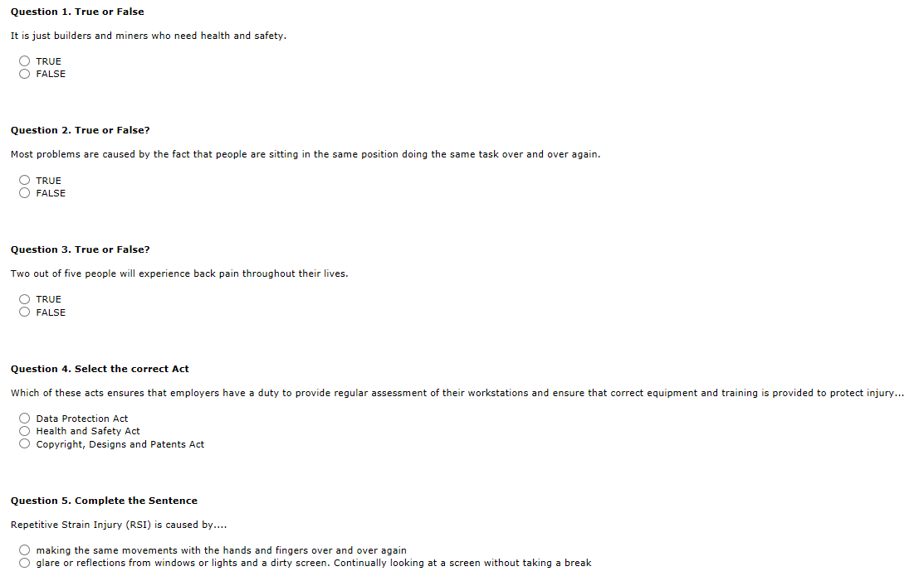

**Task 2**

Watch the YouTube video below. Then use the Forum to create a comment which:

* Describes one Potential Health Risk associated with ICT

How to prevent this potential health risk

<https://youtu.be/T8qGO7XQ0Uw>

Art

Art Task

|  |  |
| --- | --- |
| |  | | --- | | **Task – Make a collage of a landscape**  Success Criteria –   * It should be at least A4 in size * It should look like a landscape (a scene of the country side) * It should have a foreground, mid-ground and background * It should be made with torn or cut papers * S&C – Try to add some finer details | |

|  |
| --- |
|  |

|  |  |
| --- | --- |
| |  | | --- | | **What is a collage? This is an image or artwork made using torn or cut papers.**  You will need   * A4 (or bigger) paper or card * Scissors * Glue * An assortment of papers –magazines, newspapers, sweet wrappers, tissue paper, old letters, catalogues, travel brochures. You can make your own papers by painting or colouring pages and then cutting these up! * An image of a landscape to copy.   Look at the examples on the below to inspire you. | |

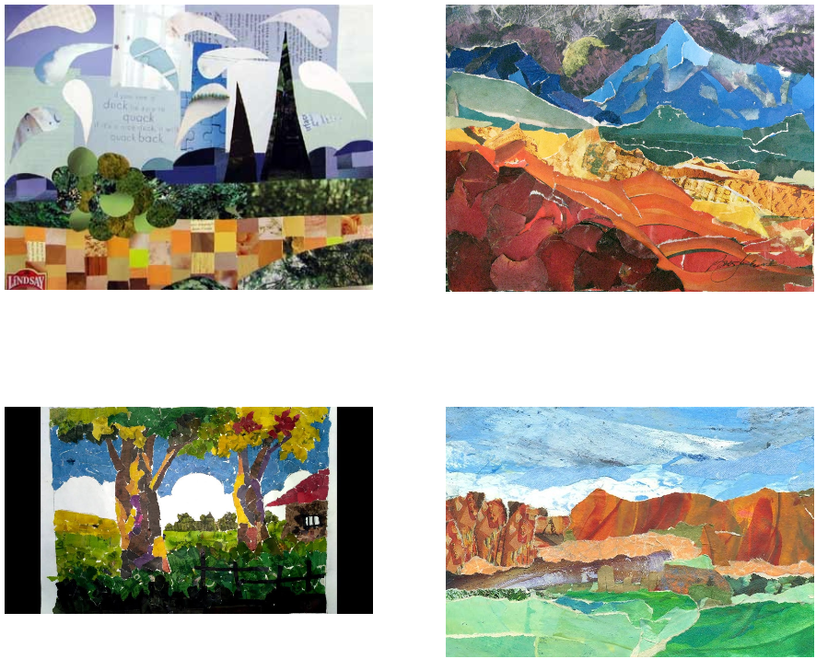

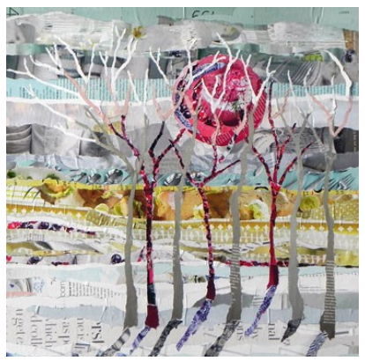

Technology

Technology Task

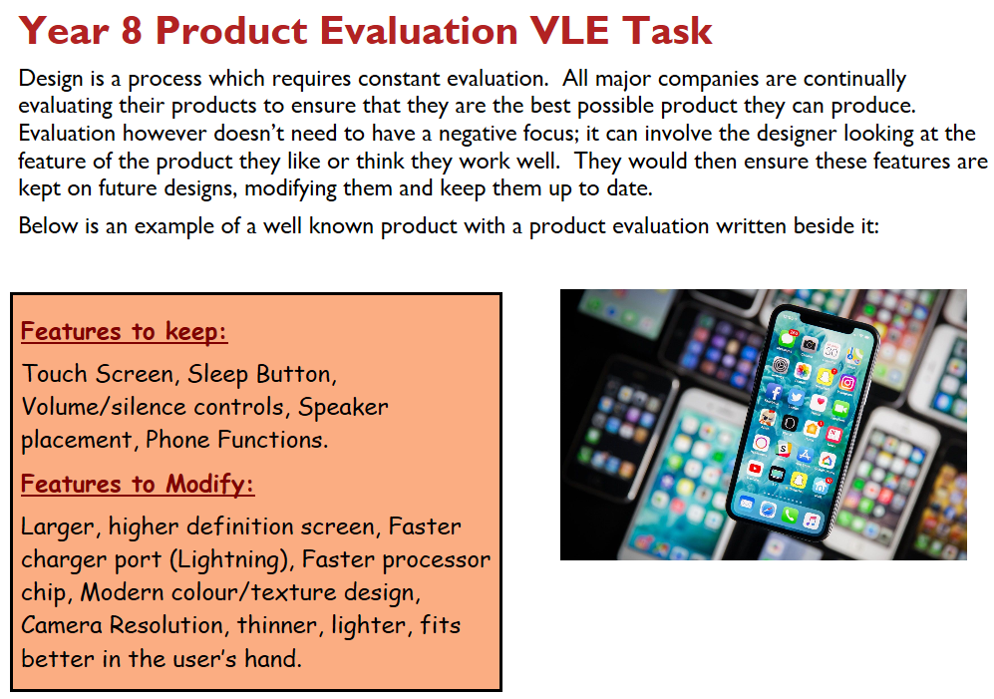

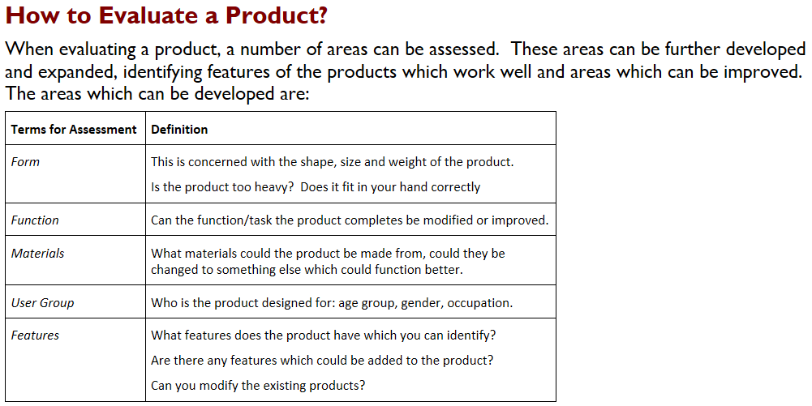

**Your Task:**

Below, you are to assess the range of products which you can find in your every day life. What features do you like, which features do you not like about the product and what would you change?

|  |  |  |  |
| --- | --- | --- | --- |
| Product | Features You Like | Features you don’t like | What would you change |
| [Image result for iphone x](https://www.google.co.uk/imgres?imgurl=http%3A%2F%2Fstatic4.businessinsider.com%2Fimage%2F5a28065bf914c360018b8430%2Fi-am-blown-away-by-the-battery-life-in-the-new-iphone-x.jpg&imgrefurl=http%3A%2F%2Fwww.businessinsider.com%2Fapple-iphone-xs-best-feature-is-its-insane-battery-life-2017-12&docid=MJYPm5xdU1bxBM&tbnid=sPtSHl2O6XpXEM%3A&vet=10ahUKEwic6efa5YbZAhVFI8AKHc89B40QMwitASgvMC8..i&w=1291&h=969&hl=en&safe=active&bih=830&biw=1280&q=iphone%20x&ved=0ahUKEwic6efa5YbZAhVFI8AKHc89B40QMwitASgvMC8&iact=mrc&uact=8) |  |  |  |
| http://sarabeck.files.wordpress.com/2012/03/coke.jpg |  |  |  |
| http://www.millies.ie/Images/ghd/ghd.jpg |  |  |  |
| http://www.acecomputersupport.co.uk/images/blackPc.gif |  |  |  |

**Mobile Phone Holder**

As you have recently completed your ‘Mobile Phone Holder ‘project, you are offered the opportunity to evaluate it. In this section you are to work on the three spider diagrams on the next page and produce as many features as you can which you liked about the project, the features which you didn’t like and the features you would like to modify the design with.

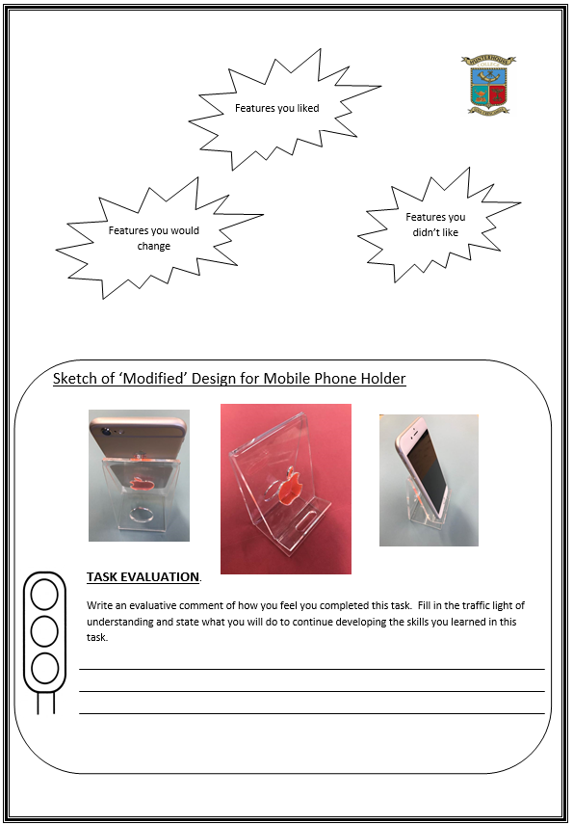 **Once you have completed the spider diagrams you are to produce a sketch of your modified project idea.** *This sketch should be annotated (have notes written around it to explain and communicate your design suggestions).*