Year 10 VLE
February

Maths

Maths Tasks
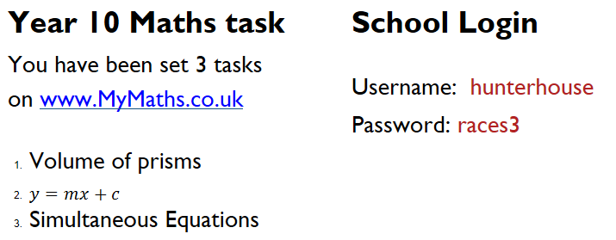
www.MyMaths.co.uk
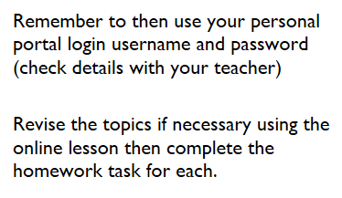

Religious
Studies

Religious Studies Task
Your task is to produce an information leaflet using Microsoft Publisher for tourists visiting the Mosque for the first time.
Your leaflet should be completed using information from your booklet and the following websites

http://www.bbc.co.uk/religion
http://www.ngfl-cymru.org.uk/vtc/ngfl/re/m_parry_carmarthenshire/addoldai/mosg/mosgtwo.html
http://www.islam.org/
http://www.belfastislamiccentre.org.uk/

Success Criteria
- Create a two fold leaflet using publisher.
- Research the mosque and use relevant information from your booklet in your leaflet.
- Explain the different activities that take place in the Mosque during the week. include at least three in your leaflet.
- Include an illustration and explanation for each feature in the Mosque. Include at least six features.
Make sure your leaflet is appropriate for a tourist visiting the mosque for the first time.

Modern Languages

French Task
There are a total of 4 activities – 2 vocabulary/phrase building activities and 2 verb activities. You can repeat them as many times as you wish. Repetition will help you learn. If you study 2 languages plan to spend up at least 40 minutes on each language. Spend more time if you only study 1 language. Be patient - it may take a moment for the activities to load. If you get lost, always return to the Fronter page.
Before your next language lesson complete the TEST and submit.

Task 1 - http://www.digitaldialects.com/French/Food.htm
Task 2 – http://www.digitaldialects.com/French/Phrases_2.htm
Task 3 - http://www.digitaldialects.com/French/Verbsinfinitive.htm
Task 4 - http://www.digitaldialects.com/French_verbs/VerbConj1.htm

French Test
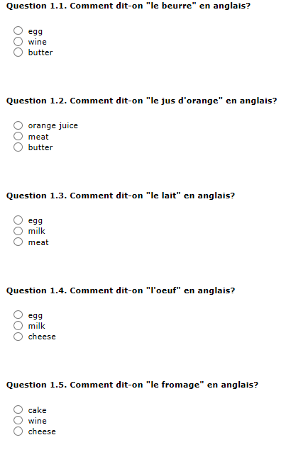

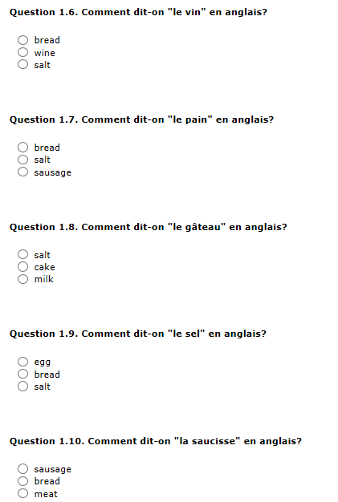

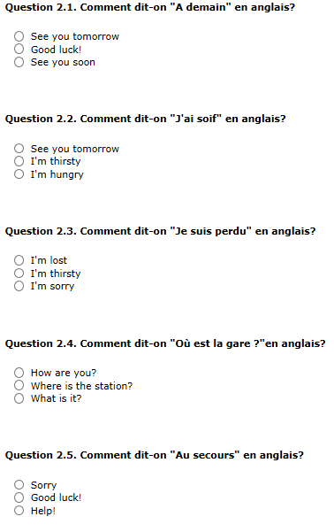

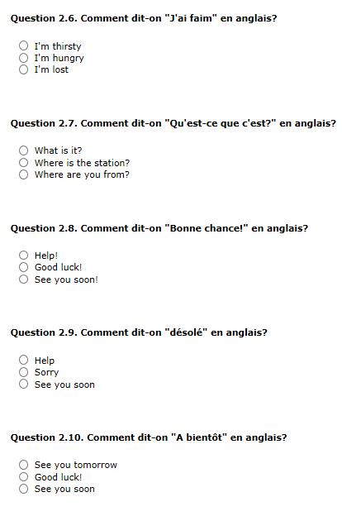

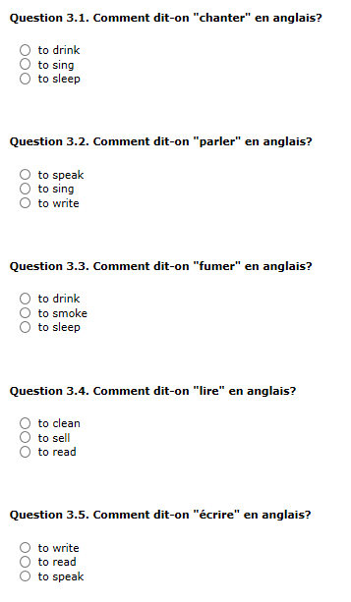

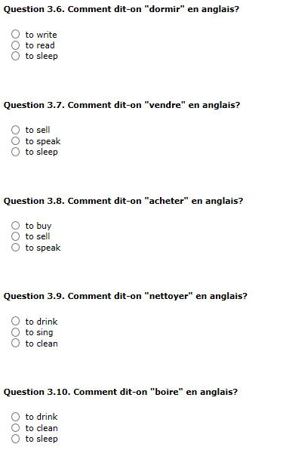

Spanish Task
There are a total of 4 activities – 2 vocabulary/phrase building activities and 2 verb activities. You can repeat them as many times as you wish. Repetition will help you learn. If you study 2 languages plan to spend up at least 40 minutes on each language. Spend more time if you only study 1 language. Be patient - it may take a moment for the activities to load. If you get lost, always return to the Fronter page.
Before your next language lesson complete the TEST and submit.

Task 1- http://www.digitaldialects.com/Spanish/Fruit.htm
Task 2 – http://www.digitaldialects.com/Spanish/Phrases_2.htm
Task 3 – http://www.digitaldialects.com/Spanish/Verbsinfinitive.htm
Task 4 – http://www.digitaldialects.com/Spanish_verbs/VerbConj2.htm

Spanish Test
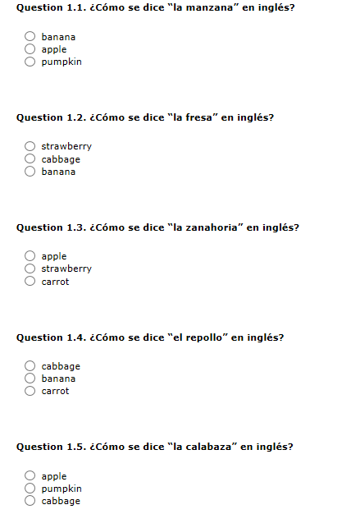

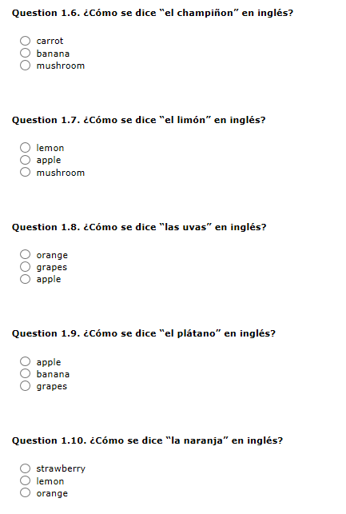

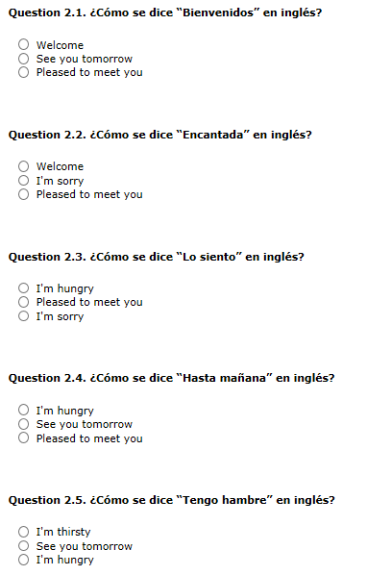

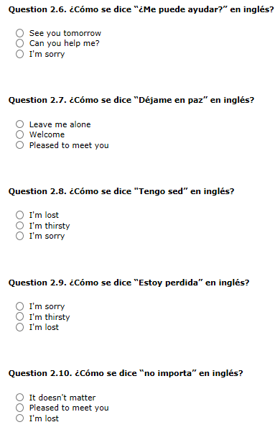

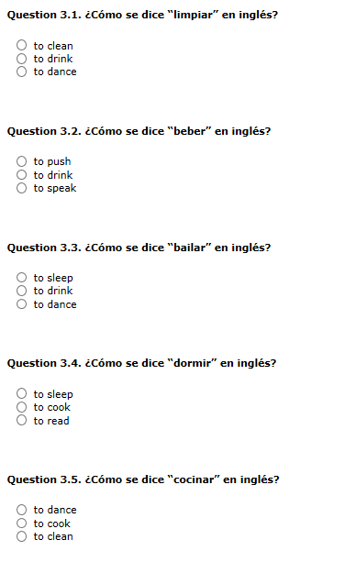

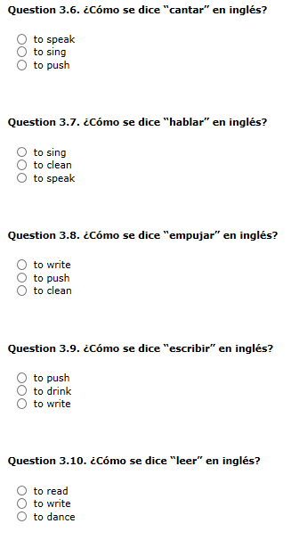

German Task
There are a total of 4 activities – 2 vocabulary/phrase building activities and 2 verb activities. You can repeat them as many times as you wish. Repetition will help you learn. If you study 2 languages plan to spend up at least 40 minutes on each language. Spend more time if you only study 1 language. Be patient - it may take a moment for the activities to load. If you get lost, always return to the Fronter page.
Before your next language lesson complete the TEST and submit.

Task 1 – http://www.digitaldialects.com/German/Clothes.htm
Task 2 – http://www.digitaldialects.com/German/Phrases_2.htm
Task 3 – http://www.digitaldialects.com/German/Verbsinfinitive.htm
Task 4 – http://www.digitaldialects.com/German/VerbConj1.htm

German Test
