**R.S**

|  |  |  |
| --- | --- | --- |
| |  | | --- | | **10 Commandments for Teenagers Today**    Your task is to produce an A4 poster with your teen commandments    Success criteria  ·         Use Microsoft Word  ·         Title: My 10 Teen Commandments  ·         List your 10 commandments with the most            important one at the top  ·         Keep them quite brief  ·         Your poster should be colourful and neatly presented  ·         Accurate spelling and grammar are necessary  ·         You must add little illustrations – 4/5 are enough | |  |

|  |  |
| --- | --- |
| |  | | --- | | **Helpful Links**  <http://quizlet.com/2789793/teens-ten-commandments-flash-cards/>  <http://www.nairaland.com/256034/ten-commandments-teenagers#3668701>  <https://www.york.ac.uk/news-and-events/news/2011/community/ten-commandments/>  [This third website is about a competition run by York University in 2011. If you go towards the end of the page you can read a number of suggested commandments from young people. Perhaps this will inspire you BUT don’t just copy and paste other people’s ideas!!]  As you can see their commandments are about a range of issues including the environment, fairness, use of technology etc. make your list of commandments as varied as possible. | |

|  |  |  |  |  |  |  |  |  |  |  |  |  |  |  |  |  |
| --- | --- | --- | --- | --- | --- | --- | --- | --- | --- | --- | --- | --- | --- | --- | --- | --- |
| |  |  |  |  |  |  |  |  |  |  |  |  |  |  | | --- | --- | --- | --- | --- | --- | --- | --- | --- | --- | --- | --- | --- | --- | | **How will your poster will be assessed?**     |  |  |  | | --- | --- | --- | |  | Met/not met - score | Teacher’s comment | | I have listed 10 teen commandments (10) |  |  | | Presentation – including drawings (10) |  | | Spelling and grammar (5) |  | Pupil comment | | Total marks (25) |  | | | |  | | --- | |  | |

**French**

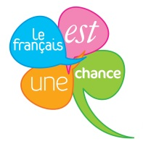

Year 9 French VLE Revision Worksheet

Expect to spend **an initial 30 minutes** on this task and then **one further homework session** before the deadline your teacher has given you.

Spending time on these exercises will help you prepare for the upcoming assessments. You will find useful vocabulary and phrases in your classwork book and in the summary vocabulary pages at the end of Module 2 in your textbook.

Your teacher will want to see evidence of your work. Either

* answer the questions on a file page,
* type your answers on this sheet and print out **or**
* save this document as “Yr9FrYOURNAME” and email as an attachment to your teacher

[cdawson791@c2kni.net](mailto:cdawson791@c2kni.net) [gmulvenna247@c2kni.net](mailto:gmulvenna247@c2kni.net) [sdevlin768@c2kni.net](mailto:sdevlin768@c2kni.net)

**Question 1**

 **What do these questions mean in English?**

1. Tu as des frères et des soeurs?
2. Où habites-tu ?
3. Tu es de quelle nationalité ?
4. Comment s’appelle ta mère/ton père ?
5. Tu as un animal ?
6. Comment est ton animal ?
7. Comment es-tu ?
8. Es-tu sportive ?

**Question 2**

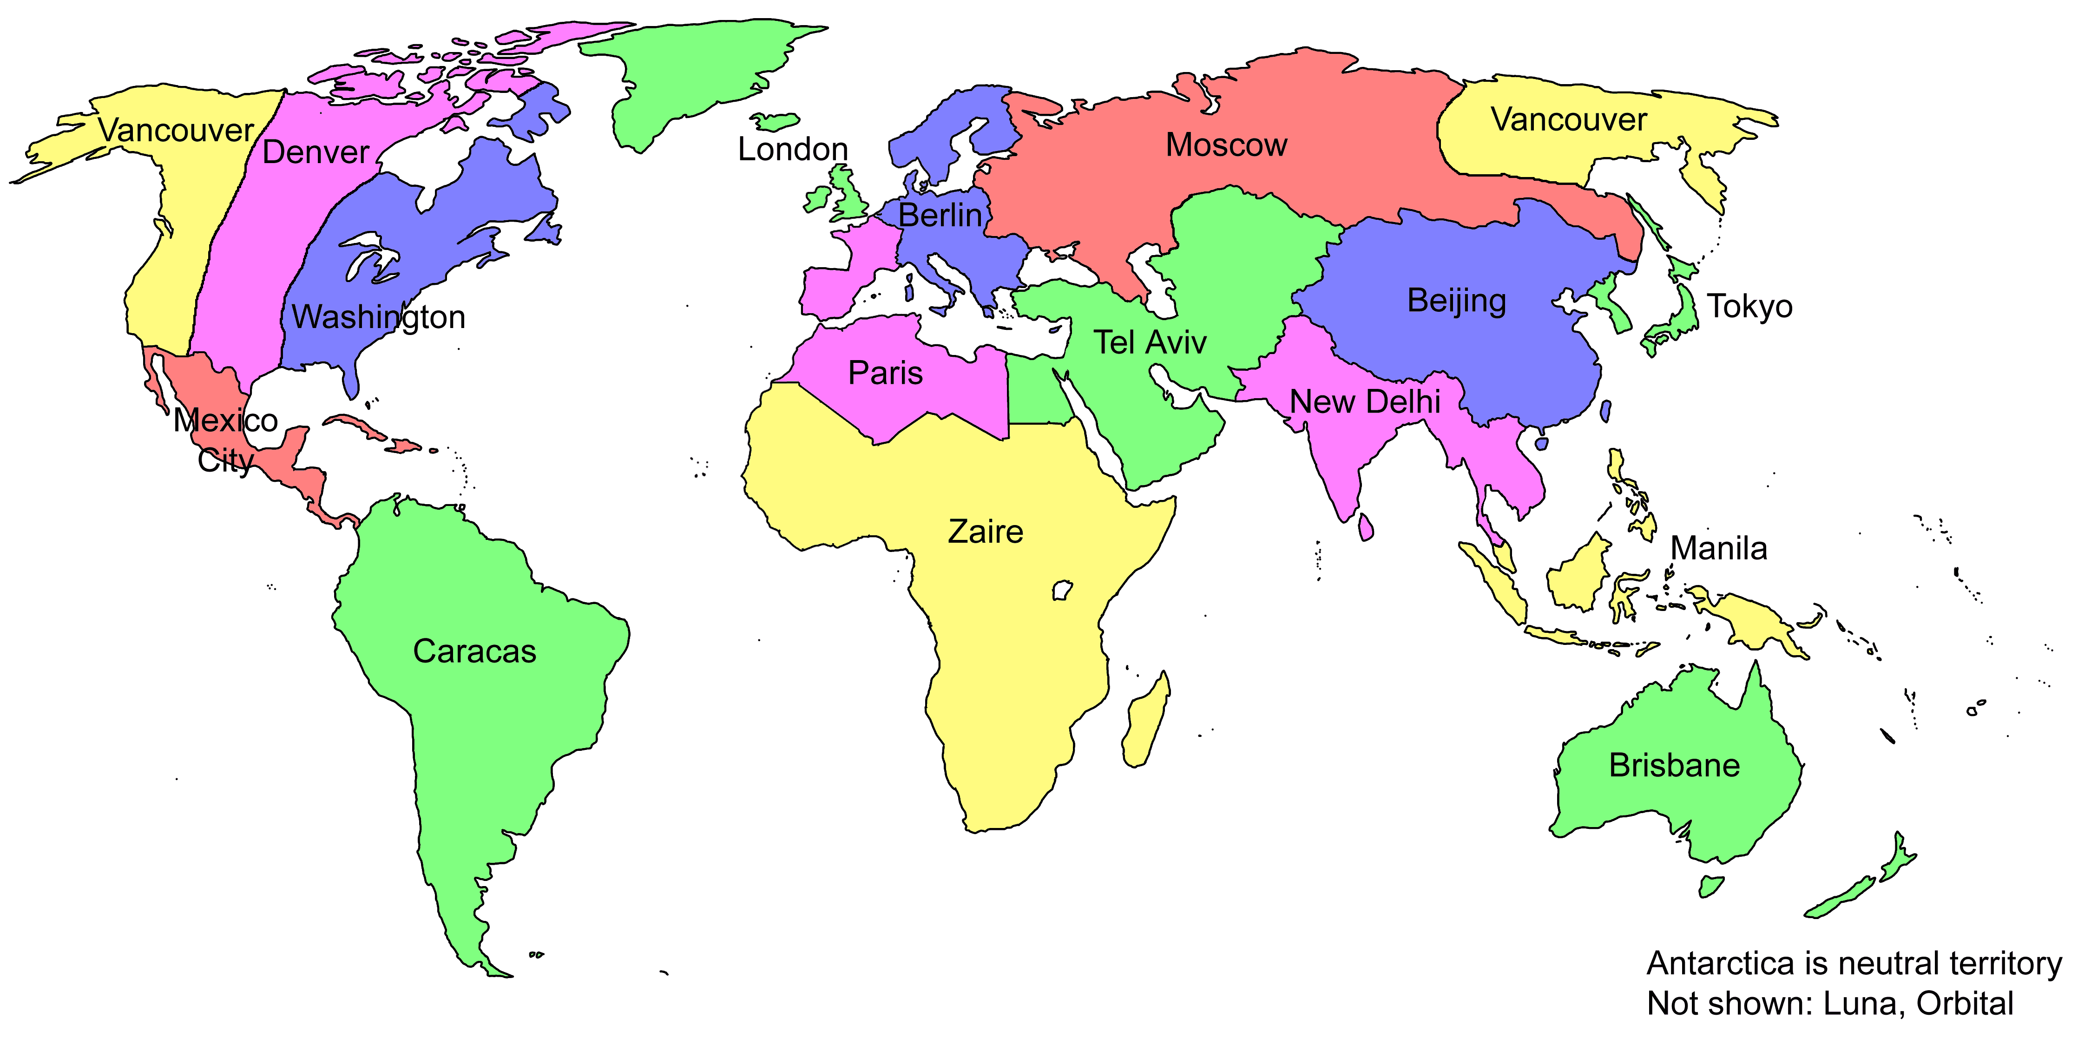 **Identify these countries**

1. L’Ecosse
2. La Belgique
3. L’Allemagne
4. Les Etats-Unis
5. La Suisse

**Now look at your resources and list 5 other countries in French.**

**Question 3**

** Match the sentence to the picture.**

1. Je suis fille unique. a. 
2. J’ai un oiseau. b. 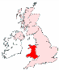 
3. Je suis gallois. c. 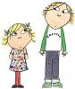
4. Ma mère est bavarde. d. 
5. J’ai un frère et une soeur . e. 

**Question 4**

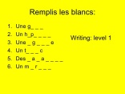 **Spelling practice. Fill in the gaps in the following groups of words\***

1. Family members m\_\_r\_\_ / p\_\_r\_\_ / fr\_\_ r\_\_\_ / s\_\_ \_\_ \_\_ r
2. Pets ch\_\_ \_\_ n / ch \_\_ t / \_\_ \_\_ s \_\_ \_\_ \_\_ / l \_\_ p \_\_ n / \_\_ r \_\_ \_\_ gn \_\_ \_\_
3. Nationalities s\_\_ \_\_ ss \_\_ / b\_\_ lg \_\_ / \_\_ ll \_\_ m \_\_ nd/ \_\_ rl \_\_ nd\_\_ \_\_ s/ \_\_ c \_\_ ss \_\_ \_\_ s
4. Colours r\_\_ \_\_ g \_\_ / bl \_\_ nch \_\_ / n\_\_ \_\_ r/ v \_\_ \_\_ l \_\_ t/ \_\_ r \_\_ ng \_\_
5. Descriptions l\_\_s y \_\_ \_\_ x bl \_\_ \_\_ s/ l\_\_ s ch\_\_ v \_\_ \_\_ x r\_\_ \_\_x / d\_\_ t\_\_ \_\_ ll \_\_ m \_\_ y \_\_ nn \_\_
6. Adjectives b \_\_ v \_\_ rd \_\_ / sp \_\_ rt\_\_ v \_\_/ m\_\_rr\_\_nt/ \_\_nn\_\_y \_\_ \_\_ s\_\_

\* To type an acute accent e.g é - Hold the AltGr key (beside space bar) and type letter

To type a grave accent ` - Type Ctrl and then ` (key to left of 1), followed by Ctrl and letter

**Question 5**

** Which is correct A or B? Circle the right one.**

A. Chien B. Chein

A . les yeux bleus B. les yeux bleue

1. Je 13 ans B. J’ai 13 ans
2. Je suis brittannique B. Je suis britannique
3. Je m’appelle B. Je mapple

**Question 6**

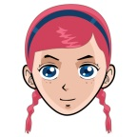 Read this text. What can you say about Catherine?

<<  Je m’appelle Catherine et j’habite à Marseille. J’ai douze ans, et mon anniversaire c’est

le seize juillet. J’ai les yeux bruns et les cheveux courts, blonds et raides. Je suis assez

petite et mince. J’ai deux sœurs et un petit frère qui a deux ans. Nous avons un chien,

un lapin et cinq poissons rouges. Et toi ? As-tu des animaux ?>>

**Now revise your notes (don’t forget your first MfI task) and write something similar about yourself.**

**Include extra details- give your nationality, say what someone in your family is called and describe one pet.**

**German**



Year 9 German VLE Revision Worksheet

Expect to spend **an initial 30 minutes** on this task and then **one further homework session** before the deadline your teacher has given you.

Spending time on these exercises will help you prepare for the upcoming assessments. You will find useful vocabulary and phrases in your classwork book and in the summary vocabulary pages at the end of Kapitel 2 in your textbook.

Your teacher will want to see evidence of your work. Either

* answer the questions on a file page,
* type your answers on this sheet and print out **or**
* save this document as “Yr9GrYOURNAME” and email as an attachment to your teacher

[dcromie552@c2kni.net](mailto:dcromie552@c2kni.net) [cdawson791@c2kni.net](mailto:cdawson791@c2kni.net)

**Question 1**

 **What do these questions mean in English?**

1. Wie heißt du?
2. Wie alt bist du?
3. Wann hast du Geburtstag?
4. Wo wohnst du?
5. Hast du Geschwister?
6. Was ist dein Lieblingsfach?
7. Wie findest du Deutsch?
8. Was isst du in der Pause?
9. Was trinkst du in der Pause?

**Question 2**

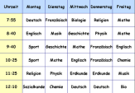 **Identify these subjects**

1. Naturwissenschaften
2. Kunst
3. Musik
4. Geschichte
5. Französisch

**Now look at your resources and list 5 other subjects in German.**

**Question 3**

**C:\Users\Family\AppData\Local\Microsoft\Windows\Temporary Internet Files\Content.IE5\QEVROJF7\link-symbol[1].png Match the sentence to the picture.**

1. Ich bin Einzelkind. a. C:\Users\Family\AppData\Local\Microsoft\Windows\Temporary Internet Files\Content.IE5\QEVROJF7\comic-boy[1].png
2. Ich findeFranzösisch gut. b. 
3. Ich esse einen Apfel. c. 
4. Ich wohne in der Schweiz. d.  
5. Ich habe einen Bruder. e. 

**Question 4**

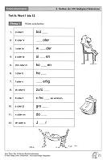 **Spelling practice. Fill in the gaps in the following groups of words**

1. Family members Br\_\_d\_\_r/ H\_\_lbbr\_\_d\_\_r/ St\_\_fbr\_\_der/ Schw\_\_st\_\_r/ H\_\_lbschw\_\_st\_\_r.
2. Snacks K\_\_ks\_\_ / d\_\_ Ch\_\_ps/ d\_\_r \_\_pf\_\_l/ d\_\_ \_\_ B\_\_n\_\_n\_\_/ d \_\_ \_\_ Sch\_\_k\_\_l\_\_d\_\_.
3. Drinks d\_\_ \_\_ C\_\_l\_\_/ d\_\_r \_\_r\_\_ng\_\_ns\_\_ft/ d\_\_ s W\_\_ss\_\_r.
4. Adjectives schl\_\_cht /int\_\_r \_\_ss\_\_nt/ l\_\_ngw\_\_ \_\_l\_\_g/ \_\_ \_\_nf\_\_ch/ schw\_\_ \_\_r\_\_g/t\_\_ll.
5. Clothes d\_\_r R\_\_ck/ d\_\_s H\_\_md/ d\_\_s Sw\_\_ \_\_tsh\_\_rt/ d\_\_s Kl\_\_ \_\_d / d\_\_ \_\_ Kr\_\_w\_\_tt\_\_.
6. Colours r\_\_t/ bl\_\_ \_\_ / g\_\_lb/br\_\_ \_\_ n /gr\_\_n/ schw\_\_rz/ gr\_\_ \_\_

\* To type ë etc - type Ctrl and : then Ctrl and letter

**Question 5**

** Which is correct A or B? Circle the right one.**

A. Mein Lieblingsfach ist.. B. Meine Leiblingsfach ist ..

A . In der Pause ich trinke Apfelsaft B. In der Pause trinke ich Apfelsaft

1. Ich habe zwei Brüder B. Ich habe zwei Bruder.
2. Ich habe am achten Februar Geburtstag.B. Ich habe am acht Februar Geburstag.
3. Die Schuhe ist schwarz . B. Die Schuhe sind schwarz.

**Question 6**

Read this text. What can you say about Katja?

**Ich heiβe Katja. Wie heiβt du? Ich wohne in Wien, das ist im Westen von Österreich. Wie geht es dir? Ich bin vierzehn Jahre alt . Wann hast du Geburtstag? Ich habe am vierzehten Oktober Geburtstag.**

**In meiner Familie gibt es fünf Personen. Meine Mutter ist zweiundvierzig Jahre alt und mein Vater ist vierundvierzig Jahre alt. Ich habe zwei Brüder, die Klaus und Thomas heißen.**

**Was ist dein Lieblingsfach? Mein Lieblingsfach ist Werken, weil es**

**wirklich lustig und einfach ist, aber ich mache Geschichte nicht**

**gern, weil ich viel schreiben muss und es ist schwierig.**

**Now revise your notes (don’t forget your first MfI task) and write something similar about yourself.**

**Include extra details if you can.**

**Spanish**

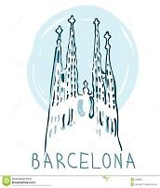

Year 9 Spanish VLE Revision Worksheet

Expect to spend **an initial 30 minutes** on this task and then **one further homework session** before the deadline your teacher has given you.

Spending time on these exercises will help you prepare for the upcoming assessments. You will find useful vocabulary and phrases in your classwork book and in the summary vocabulary pages at the end of Module 2 in your textbook.

Your teacher will want to see evidence of your work. Either

* answer the questions on a file page,
* type your answers on this sheet and print out **or**
* save this document as “Yr9SpYOURNAME” and email as an attachment to your teacher

[amcclenaghan243@c2kni.net](mailto:amcclenaghan243@c2kni.net) [sdevlin768@c2kni.net](mailto:sdevlin768@c2kni.net)

**Question 1**

 **What do these questions mean in English?**

1. ¿De dónde eres?
2. ¿Tienes hermanos?
3. ¿Cómo se llama tu madre/tu padre?
4. ¿Dónde vives?
5. ¿Cúal es tu nacionalidad?
6. ¿Tienes un animal en casa?
7. ¿Qué idiomas hablas?
8. ¿Cómo eres?

**Question 2**

 **Identify these countries**

1. Estados Unidos
2. Alemania
3. Gales
4. Suiza
5. Inglaterra

**Now look at your resources and list 5 other countries in Spanish.**

**Question 3**

** Match the sentence to the picture.**

1. Tengo un pájaro. a. 
2. Soy hija única. b.  
3. Tengo un hermano y una hermana. c. 
4. Soy galesa . d. 
5. Tengo el pelo largo y ondulado . e. 

**Question 4**

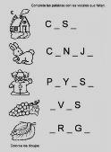 **Spelling practice. Fill in the gaps in the following groups of words\***

1. Family members m\_\_dr\_\_ / p\_\_dr\_\_ / h\_\_ rm\_\_\_no / h \_\_ m\_\_n \_\_
2. Pets c\_\_ n\_\_ j\_\_ / c \_\_b \_\_ ll\_\_ / t\_\_rt \_\_ g \_\_ /g\_\_ t\_\_ / p\_\_ c \_\_ s / c\_\_b\_\_y\_\_
3. Nationalities s\_\_ \_\_ z \_\_ / esc\_\_ c \_\_ s/ br\_\_ t\_\_n\_\_c\_\_/ \_\_t\_\_l\_\_ \_\_n \_\_/ \_\_l\_\_m\_\_
4. Colours n\_\_ g r\_\_ / bl \_\_ nc \_\_ / v\_\_ rd\_\_ / am\_\_r \_\_ ll \_\_ / m\_\_ rr \_\_ n
5. Descriptions l\_\_s \_\_j \_\_ s \_\_z \_\_l \_\_ s/ \_\_l p\_\_ l \_\_ r\_\_ b \_\_ \_\_ / \_\_l p\_\_l\_\_ l\_\_s\_\_
6. Adjectives p\_\_q\_\_ \_\_ ñ\_\_ / gr\_ nd\_\_ / \_\_lt\_\_ / b \_\_ j \_\_

\* To type an accent e.g é - Hold the AltGr key (beside space bar) and type letter

To type a ñ - Type Ctrl, shift and ~ (above#) then followed by Ctrl and n

**Question 5**

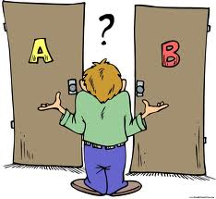 **Which is correct A or B? Circle the right one.**

A. Me lama B. Me llamo

A . los ojos verdes B. los ojos rizados

1. Hablo francés B. Hablo francia
2. El pelo pelirrojo B. El pelo rojo
3. Mi ratón es grande B. Mi caballo es pequeña

**Question6**

** Read this text. What can you say about Ana María?**

bl00261_Hola, me llamo Ana María y tengo doce años. Soy española. Vivo en Salamanca.

Soy bastante alta y delgada. Tengo el pelo corto y rubio y los ojos marrones.

En mi familia hay cinco personas: mi padre, mi madre mis dos hermanos y yo. Mi padre se llama Pedro. Tiene cuarenta y cinco años y mi madre se llama Juana. Mi hermano mayor se llama Alberto. Tiene quince años. Mi hermano pequeño se llama Blas. También tengo un perro que se llama Toby. Es blanco y negro y muy pequeño.

**Now revise your notes (don’t forget your first MfI task) and write something similar about yourself.**

**History**

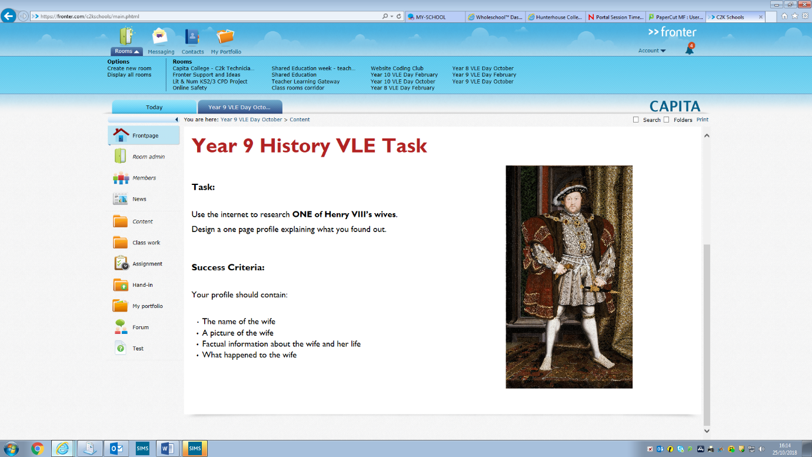

**Art**

