Hunterhouse College

Year 8

VLE

Name: __________________________

Class: 8______

Teacher: ________________________

ICT

Hunterhouse College

Year 8

ICT

VLE

Name: __________________________

Class: 8______

Teacher: ________________________

Your Marks (this will be completed in class)

Homework | Mark | Teacher Comment
Number
1 | / 6
2 | / 7
3 | / 8
Total | /21

After you have completed the last homework, complete the section below (*circle the option that you agree with and then complete the statement):

- I *did/did not find that this booklet stretched my understanding of the subjects that I learnt in class because ______________________________

_____________________________________________________________

_____________________________________________________________

- Completing work at home *is/is not important because ________________

___________________________________________________________

VLE 1

Internet Safety

The Internet can be a very dangerous place and there are many websites that help you to be safe e.g. www.kidsmart.org.uk, www.thinkuknow.co.uk and www.wisekids.org.uk.

- Draw a character that could be used by one of these sites

- Inside the speech bubble describe your favourite thing about the Internet and give one piece of advice for using the Internet safely

An example has been provided at the bottom of the page.
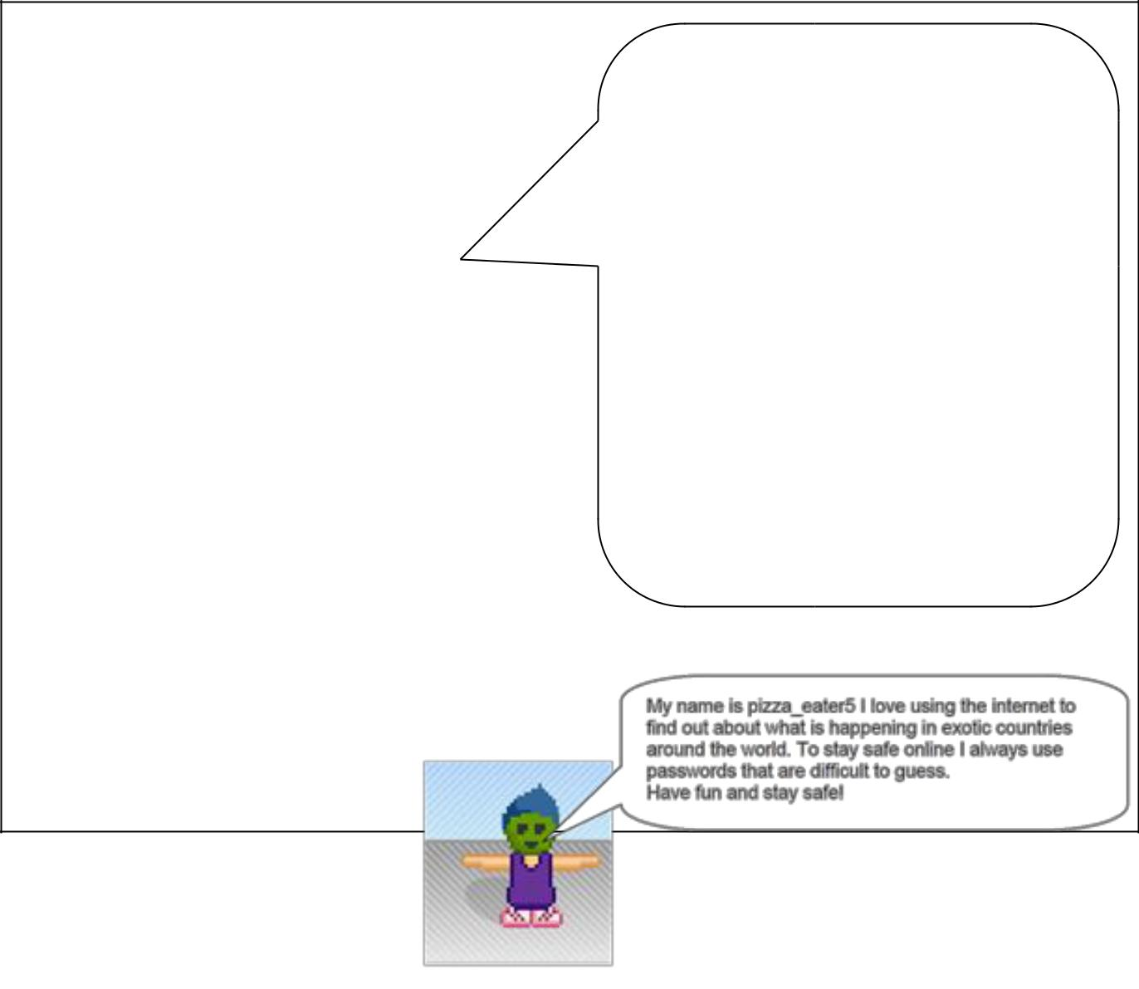

Draw your character here:

6 Marks:
Example
3 marks for your character

3 marks for the content of the speech bubble

Comment:

3

VLE 2

The Internet

Use the word bank to complete the grid below:
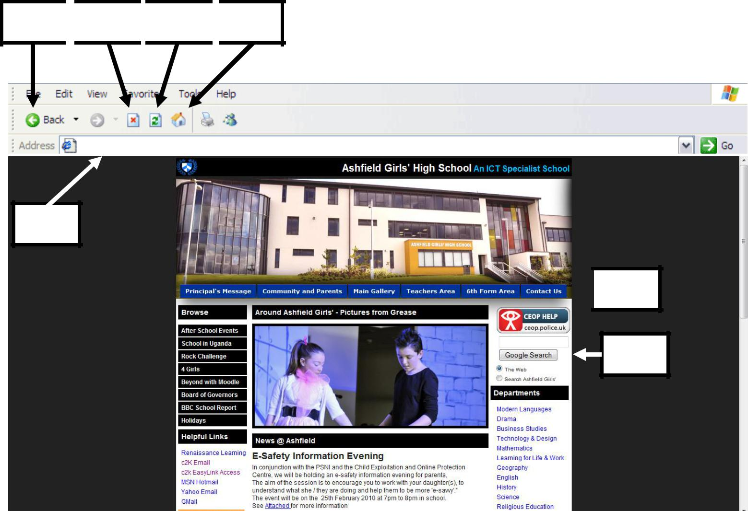

1 2 3 4

http://www.ashfieldgirls.org

5

1

2

3

4

5

6

7

4

7

6

Word Bank

Refresh Button

Home Page Button

Back Button

Search Engine

Address Bar

Stop Button

Internet Safety Help

Comment:

VLE 3

Using the Internet

Answer the following questions:

- Is Internet Explorer an example of a Search Engine or a Web Browser?

_______________________________________________________

- Is Google an example of a Search Engine or a Web Browser?

_______________________________________________________

- Describe how you would find out the opening times of the Holywood Ice Bowl using the Internet

_______________________________________________________

_______________________________________________________

_____________________________________________________ [3]

- Describe what we use ‘Favourites’ for

_______________________________________________________

_______________________________________________________

_____________________________________________________ [2]

- Describe 1 danger of using the Internet

_______________________________________________________

Comment:
5

MATHS

Maths
Year 8 Maths task
You have been set 3 tasks
on www.MyMaths.co.uk
- Order of Operations
- Factors and Primes
- Multiples
Revise the topics if necessary
using the online lesson then complete
the homework task for each.
School Login: hunterhouse
Password: races3

Remember to then use your
personal portal login username
and password (check details with
your teacher)

MyMaths is available on both PC or Laptop and on most tablets and mobile devices including ipads through Puffin Academy which is a free mobile and tablet Flash browser. You may need to download the Puffin Academy App if you are using a tablet.

The tasks are due to be completed on 26th October 2018. If you have any problems, speak to your Maths teacher when you return to school.

English

Music

Year 8 VLE Day October: Music
Use You Tube and online dictionaries to help you with this homework. If you do not have a computer at home, complete the work in school. You will not be able to access You Tube in school but there will be other sites where you can hear music.
THE TASK
- Type the names of the instruments listed below (violin, cello, flute, trumpet and trombone) into You tube etc.
- Listen to a piece of music being played by each of these 5 orchestral instruments.
- Write the name of the 5 pieces of music you listen to.
- Then write a few sentences about the music. Use these words to help you: is it loud/soft; is it fast/slow/medium speed; is it happy music/sad music; do you think that the music is telling a story? What is this story? Is there anything else that you think is interesting about the music?
You can either complete the work on computer and then print it off, or write by hand.
Remember to bring the completed work to your first music class after half term.
It is expensive to print in colour, so black ink is perfectly fine.
The Violin
Listen to a clip of music played by the violin.
Name the piece:
Write a few sentences about the music you chose:
The Cello
Listen to a clip of music played by the cello.
Name the piece:
Write a few sentences about the music you chose:

The Flute
Listen to a clip of music played by the flute.
Name the piece:
Write a few sentences about the music you chose:

The Trumpet
Listen to a clip of music played by the cello.
Name the piece:
Write a few sentences about the music you chose:

The Trombone
Listen to a clip of music played by the trombone.
Name the piece:
Write a few sentences about the music you chose:

H.E
Year 8
Eatwell Guide
Within Home Economics it is important to learn about a healthy diet to ensure we are developing good eating habits and maintaining good health.
To understand what a healthy diet is we use the model of the EATWELL GUIDE

Go to https://www.nutrition.org.uk/healthyliving/healthydiet/eatwell.html
Copy a picture of the Eatwell Guide into the space below:-

Using the information provided on the website to complete the Eatwell Guide below:-
- Label each section of the Eatwell Guide
- Research and paste five pictures of relevant foods into each section of the plate
- When complete print your work (preferably in colour) and bring it to class next day
