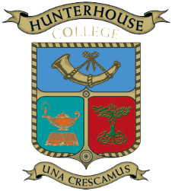

All past pupils and staff
of Princess Gardens, Ashleigh House and Hunterhouse College
are invited to attend the reunion
which marks
the 150th Anniversary Celebration of PG
and celebrates
the Learmount Castle years of AHS

Saturday 20th June 2015
7.00 p.m. for 7.30 p.m.

Colinmore House
Hunterhouse College, Finaghy, Belfast BT10 0LE

The Memorabilia Room/Heritage Room and Main School
with displays of photographs
will be open from 6.00 p.m. until late.

Honey and ginger chicken (with creamy sauce)

Salmon with herb sauce

Carrot and chestnut cannelloni with watercress sauce

Spring vegetables and baby potatoes

Panacotta with pears poached in port

Tea and Coffee

Wine and soft drinks included
£20

Please complete the form on the next page.

We will not issue tickets but if you include an email or telephone number we will contact you to confirm that a place has been reserved for you at the dinner.

Title  (Please delete as appropriate) | Miss/Ms/Mrs/Dr/Other
Forename
Surname
Née
Telephone
Mobile
e-mail
Address
POSTCODE
School  (Please delete as appropriate) | Princess Gardens / Ashleigh House / Hunterhouse College
Years attended
Other information

Please complete the amount and tick the relevant boxes below:

I have enclosed a cheque for £ __________ (£20 per person) made payable to Hunterians OGA
I have hand delivered cash £__________ (£20 per person) to Reception at Hunterhouse College
I have paid £__________ (£20 per person) by PayPal to hunterians.oga@gmail.com

Inquiries:
028 9061 2293
hunterians.oga@gmail.com

Send the completed form to:
Hunterians OGA, Hunterhouse College, Finaghy, BELFAST BT10 0LE

(If paying by PayPal you may wish to email the form to hunterians.oga@gmail.com)

